Aim

Write a program to define the function template for swapping two items of various datatypes such as integers, float and characters.

Experiment - 29

Object Oriented Programming Lab

Syeda Reeha Quasar

14114802719

4C7

# **EXPERIMENT – 29**

## **Aim:**

Write a program to define the function template for swapping two items of various datatypes such as integers, float and characters.

## **Source Code:**

#include <iostream>

using namespace std;

template <typename T>

void Swap(T &n1, T &n2)

{

    T temp;

    temp = n1;

    n1 = n2;

    n2 = temp;

}

int main()

{

    int i1 = 6, i2 = 3;

    float f1 = 7.2, f2 = 4.5;

    char c1 = 'p', c2 = 'x';

    cout << "Before passing data to function template.\n";

    cout << "i1 = " << i1 << "\ni2 = " << i2;

    cout << "\nf1 = " << f1 << "\nf2 = " << f2;

    cout << "\nc1 = " << c1 << "\nc2 = " << c2;

    Swap(i1, i2);

    Swap(f1, f2);

    Swap(c1, c2);

    cout << "\n\nAfter passing data to function template.\n";

    cout << "i1 = " << i1 << "\ni2 = " << i2;

    cout << "\nf1 = " << f1 << "\nf2 = " << f2;

    cout << "\nc1 = " << c1 << "\nc2 = " << c2;

    return 0;

}

## **Output:**

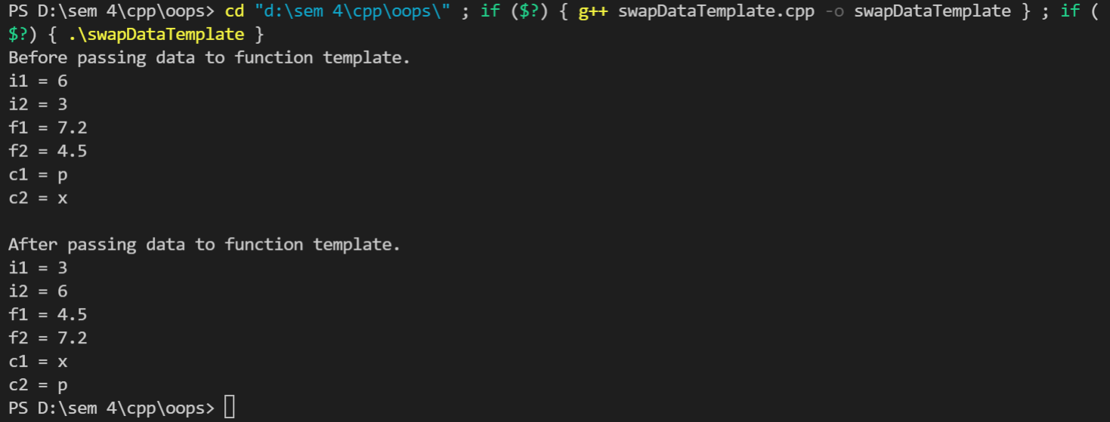

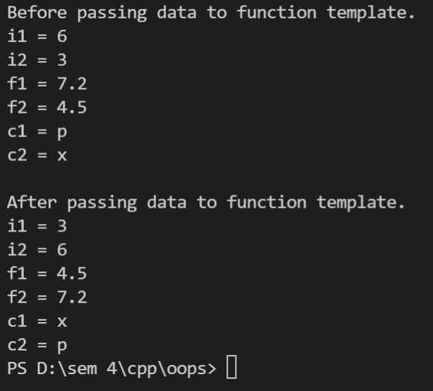

# **Viva Questions**

**Q1). What are templates in C++?**

Ans.

Templates are the foundation of generic programming, which involves writing code in a way that is independent of any particular type.

A template is a blueprint or formula for creating a generic class or a function. The library containers like iterators and algorithms are examples of generic programming and have been developed using template concept.

There is a single definition of each container, such as **vector**, but we can define many different kinds of vectors for example, **vector <int>** or **vector <string>**.

**Q2). How can templates be classified?**

Ans.

**Templates can be represented in two ways:**

* Function templates
* Class templates

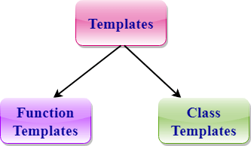

**Function Templates:**

We can define a template for a function. For example, if we have an add() function, we can create versions of the add function for adding the int, float or double type values.

**Class Template:**

We can define a template for a class. For example, a class template can be created for the array class that can accept the array of various types such as int array, float array or double array.

**Q3). Write about Function templates.**

Ans.

* C++ supports a powerful feature known as a template to implement the concept of generic programming.
* A template allows us to create a family of classes or family of functions to handle different data types.
* Template classes and functions eliminate the code duplication of different data types and thus makes the development easier and faster.
* Multiple parameters can be used in both class and function template.
* Template functions can also be overloaded.
* We can also use nontype arguments such as built-in or derived data types as template arguments.

**Q4). What are different Data types?**

Ans.

|  |  |  |
| --- | --- | --- |
| Data Type | Meaning | Size (in Bytes) |
| int | Integer | 2 or 4 |
| float | Floating-point | 4 |
| double | Double Floating-point | 8 |
| char | Character | 1 |
| wchar_t | Wide Character | 2 |
| bool | Boolean | 1 |
| void | Empty | 0 |